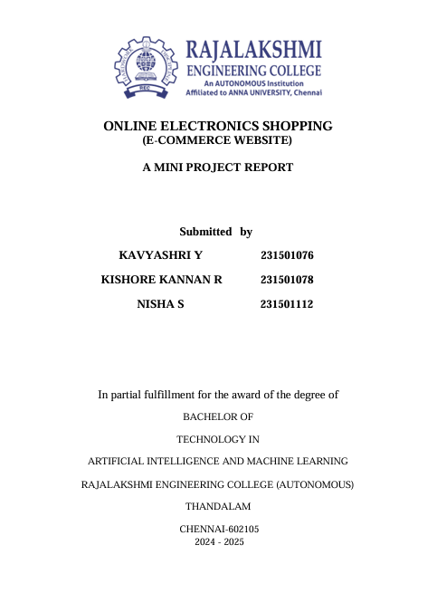

**DATA SCIENCE**

**Ilakkiya R 231801060**

**Haritha M 231801051**

**TABLE OF CONTENTS**

**1. INTRODUCTION**

1.1 INTRODUCTION……………………………………………………………….

1.2 OBJECTIVES……………………………………………………………………

1.3 MODULES………………………………………………………………………

**2. SURVEY OF TECHNOLOGIES**

2.1 SOFTWARE DESCRIPTION…………………………………………………..

2.2 LANGUAGES…………………………………………………………………..

2.2.1 MySQL………………………………………………………....

2.2.2 Python Tkinter…………………………………………..…

**3. REQUIREMENTS AND ANALYSIS**

3.1 REQUIREMENT SPECIFICATION………………………………….……

3.2 HARDWARE AND SOFTWARE REQUIREMENTS………………….

3.3 DATA DICTIONARY……………………………………………………

3.4.ER DIAGRAM………………………………………………………….......

**4.PROGRAM CODE ……………………………………………………….…………………**

**5. RESULTS AND DISCUSSIONS……………………………………………..………....**

**6. CONCLUSION…………………………………………………………………..............**

**7. REFERENCES……………………………………………………………………………..**

**Abstract**

A **Salary Management System** is a specialized software solution designed to efficiently manage employee compensation within an organization. It automates the processes of calculating salaries, managing deductions, applying benefits, and ensuring compliance with tax regulations. By replacing manual methods, it reduces the risk of errors, saves time, and enhances overall operational efficiency.

The system centralizes employee data, including attendance, overtime, bonuses, and leaves, to compute accurate salary details. It also facilitates the generation of payslips, tax filings, and financial reports, streamlining the payroll workflow. Additionally, it integrates with banking systems for direct salary disbursement, ensuring timely and secure payments.

A Salary Management System provides a user-friendly interface for HR and finance teams while offering employees access to their payment history and details. With features like data encryption and role-based access, it ensures the confidentiality and security of sensitive financial data. Furthermore, cloud-based systems enable scalability and remote accessibility, making them ideal for organizations of all sizes.

**INTRODUCTION**

* 1. **INTRODUCTION**

A **Salary Management System** is a comprehensive solution designed to streamline and automate the management of employee salaries in an organization. It addresses the complexities of salary computation by integrating various factors, such as employee attendance, overtime, deductions, bonuses, and tax regulations. This system ensures accurate and timely processing of salaries, reducing the administrative burden on HR and finance departments while enhancing overall efficiency.

In traditional setups, salary management involves time-consuming manual processes prone to errors and inconsistencies. A Salary Management System eliminates these challenges by automating payroll workflows, ensuring precise calculations, and maintaining compliance with labor laws and tax requirements. It also provides tools for generating payslips, maintaining financial records, and offering employees access to their salary details through a secure and user-friendly platform.

With features like direct salary disbursement, real-time data updates, and customizable reports, the system supports decision-making and improves financial transparency. Whether deployed in small businesses or large enterprises, it is a scalable and adaptable tool that meets the unique needs of various industries. By integrating with other business systems, such as attendance trackers and accounting software, it creates a unified ecosystem for efficient payroll management.

In summary, a Salary Management System is a vital resource for organizations looking to optimize payroll operations, enhance accuracy, and improve employee satisfaction.

**1.2 OBJECTIVES**

• **Automate Payroll Processes:**  
Streamline the calculation of salaries, deductions, taxes, and benefits to reduce manual effort and errors.

• **Ensure Accuracy:**  
Provide precise and error-free computations by incorporating employee attendance, overtime, bonuses, and leave data.

• **Enhance Efficiency:**  
Minimize the time required for salary processing, report generation, and payment disbursement.

• **Improve Compliance:**  
Ensure adherence to tax laws, labor regulations, and organizational policies by keeping the system updated with regulatory changes.

• **Secure Financial Data:**  
Safeguard sensitive payroll and employee information using robust encryption and access control mechanisms.

• **Generate Reports:**  
Enable easy creation of detailed reports for audits, tax filings, and internal analysis to support decision-making.

• **Facilitate Transparency:**  
Provide employees with easy access to their salary details, payslips, and deductions through a secure portal.

• **Enable Scalability:**  
Adapt to the growing needs of the organization, accommodating an increasing workforce and additional payroll requirements.

• **Integrate with Financial Systems:**  
Seamlessly connect with accounting and banking systems to automate salary transfers and maintain accurate financial records.

• **Reduce Administrative Burden:**  
Free up HR and finance teams to focus on strategic tasks by automating routine payroll activities.

**MODULES**

**Employee Information Management**

* Stores and manages employee data such as personal details, job roles, department, and salary structure.
* Tracks employment history, joining dates, and promotions.

**Attendance and Leave Management**

* Integrates with attendance systems (e.g., biometric or timesheets) to record working hours.
* Tracks leaves, holidays, overtime, and late arrivals to calculate salary adjustments.

**Salary Calculation**

* Automates gross salary calculation by factoring in:
  + Basic pay
  + Allowances (HRA, DA, etc.)
  + Bonuses and incentives
  + Deductions (PF, taxes, loans, etc.)
* Handles prorated salaries for partial months.

**Taxation and Compliance**

* Computes income tax, professional tax, and other statutory deductions.
* Generates Form 16, TDS certificates, and other tax-related documents.
* Ensures compliance with local labor and tax laws.

**II. SURWAY OF TECHNOLOGY**

**2.1Software description**

The **Salary Management System** is a comprehensive software application designed to automate and simplify the management of employee compensation within an organization. It efficiently handles various payroll-related tasks, including salary computation, tax deductions, benefits processing, and compliance with labor laws.

### **Key Features:**

1. **Employee Data Management:** Maintain comprehensive records of employee profiles, salaries, bonuses, and deductions.
2. **Salary Calculation:** Automate gross and net salary calculations, including overtime, bonuses, and deductions.
3. **Tax and Compliance Management:** Stay updated with the latest tax regulations and generate accurate tax reports and filings.
4. **Payslip Generation:** Generate and distribute detailed payslips to employees.
5. **Integration:** Seamlessly integrate with attendance systems and banking platforms.
6. **Reporting and Analytics:** Generate detailed financial reports and payroll analytics to support decision-making.
7. **Security:** Protect sensitive payroll data with encryption and role-based access control.
8. **Scalability:** Adapt to organizations of various sizes and support cloud-based access.

### **Benefits:**

* Reduces manual errors and ensures accurate salary processing.
* Saves time by automating repetitive payroll tasks.
* Enhances employee satisfaction through timely and transparent salary disbursement.
* Improves compliance with legal and tax obligations.
* Offers scalability for growing businesses.

**2.2 Languages**

**MySQL**

**MySQL** is employed to store and manage essential data such as employee details, salary structures, attendance records, and payroll history. Its robust relational database structure allows for efficient data handling and ensures the system remains scalable and reliable.

**Key Features of MySQL in This System:**

1. **Data Integrity**: Supports ACID properties, ensuring accurate and reliable payroll transactions.
2. **Scalability**: Handles large amounts of employee and payroll data as the organization grows.
3. **Efficiency**: Optimized query performance for retrieving and managing salary records.
4. **Security**: Advanced authentication and encryption features protect sensitive financial data.
5. **Flexibility**: SQL queries allow for complex operations such as calculating salaries, generating reports, and tracking attendance.

**Python Tkinter**

**Python Tkinter** serves as the graphical interface, enabling users to interact with the system through windows, buttons, and input fields. Administrators can manage employee data and generate payroll, while employees can view their salary details and payslips.

**Key Features of Python Tkinter in This System:**

**Ease of Use**: Simplifies the creation of forms, data entry screens, and reports.

**Cross-Platform**: Compatible with Windows, macOS, and Linux for wide accessibility.

**Event-Driven Programming**: User actions, such as button clicks or data entry, trigger salary calculations and database updates.

**Integration with Python**: Enables the use of Python libraries for database connectivity and data processing.

**Lightweight**: Ideal for a desktop-based salary management system without the need for heavy frameworks.

**Integration of MySQL and Tkinter**

The integration combines MySQL’s robust data management capabilities with Tkinter’s intuitive user interface to build an efficient salary management system. Python libraries like mysql-connector or pymysql are used to connect the Tkinter front-end with the MySQL database.

**III Requirements and analysis**

**3.1 Requirements Specification**

**User Requirements**

• **Employees**:

* Employees should be able to view their salary details, including components like basic salary, bonuses, and deductions.
* Employees should be able to access their payslips for different months and years.
* Employees can view their attendance status and any leave records affecting their pay.

• **Administrators**:

* Administrators should have the ability to add, edit, and remove employee data.
* Administrators should be able to configure and modify salary components (e.g., basic salary, bonuses, deductions).
* Administrators can generate and view payroll reports for multiple employees at once.
* Administrators should have the ability to process payroll for all employees, ensuring that payments are made on time.

**System Requirements**

* The system will be built using **Python** with **Tkinter** for the graphical user interface and **MySQL** as the back-end database to store employee data, salary information, and payroll records.
* The system should run on any major operating system (Windows, macOS, or Linux) with **Python 3.x** installed.
* **MySQL** should be configured on the system for data storage.
* Basic hardware will include a desktop or laptop with at least **4 GB of RAM** and **500 MB of available disk space**.
* The system should ensure **secure login** for administrators and employees, with **data encryption** to protect sensitive payroll information.

**3.2 HARDWARE AND SOFTWARE REQUIREMENTS**

**Software Requirements**

* **Operating System**: Windows 10 or 11, macOS, Linux
* **Front End**: Python (Tkinter)
* **Back End**: Python, MySQL, Python MySQL Connector
* **Database**: MySQL (Version 5.7 or above)
* **Other Tools**: Python 3.x, Python libraries like mysql-connector, tkinter, pandas (for reports)

**Hardware Requirements**

* **Hardware**:
  + Desktop PC or Laptop
  + Printer (optional, for printing payslips)
* **System Specifications**:
  + **Operating System**: Windows 10 or higher (64-bit), macOS, or Linux
  + **Processor**: Intel® Core™ i3-6006U CPU @ 2.00GHz or higher
  + **RAM**: 4.00 GB or higher
  + **Disk Space**: 500 MB available disk space
  + **Display**: Monitor resolution of 1024 x 768 or higher
  + **Input Devices**: Keyboard and Mouse

3.3 DATA DICTIONARY

Attendance Tracks the attendance records of each employee daily. Schema: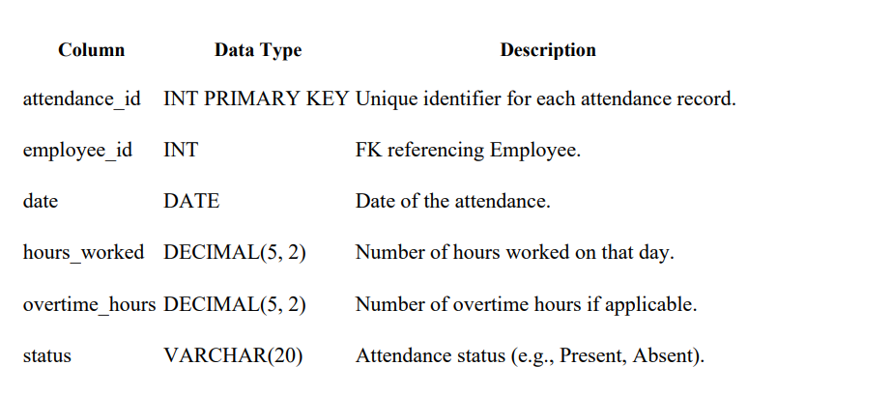

2. Leave Manages the leave requests submitted by employees. Schema:

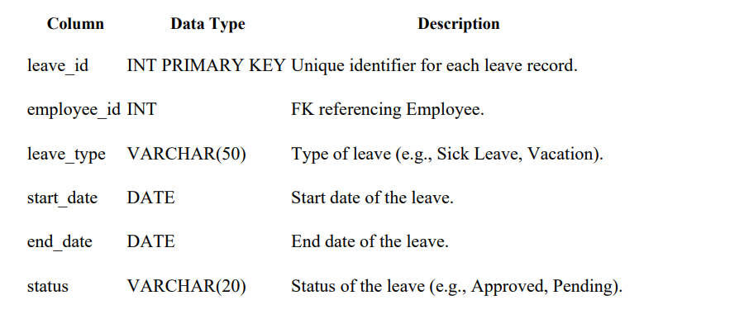

3. Payslip Represents the payslip generated for each payroll record. Schema:

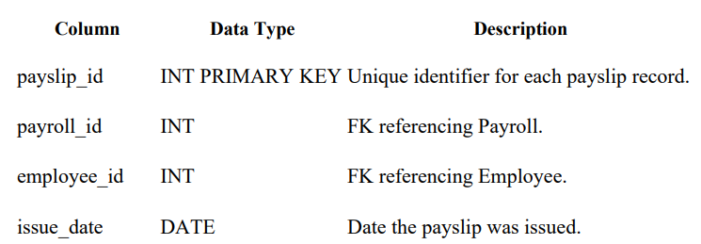

**IV. PROGRAM CODE**

**# Salary Management System**

**# File to store employee data**

**EMPLOYEE_FILE = "employees.txt"**

**# Function to add an employee**

**def add_employee():**

**name = input("Enter employee name: ")**

**id = input("Enter employee ID: ")**

**salary = float(input("Enter salary: "))**

**with open(EMPLOYEE_FILE, "a") as file:**

**file.write(f"{id},{name},{salary}\n")**

**print(f"Employee {name} added successfully!")**

**# Function to view all employees**

**def view_employees():**

**print("\nEmployee Details:")**

**print("-" * 30)**

**try:**

**with open(EMPLOYEE_FILE, "r") as file:**

**for line in file:**

**id, name, salary = line.strip().split(",")**

**print(f"ID: {id}, Name: {name}, Salary: {salary}")**

**except FileNotFoundError:**

**print("No employee data found. Add employees first.")**

**# Function to calculate bonus**

**def calculate_bonus():**

**id = input("Enter employee ID to calculate bonus: ")**

**try:**

**with open(EMPLOYEE_FILE, "r") as file:**

**for line in file:**

**emp_id, name, salary = line.strip().split(",")**

**if emp_id == id:**

**salary = float(salary)**

**bonus = 0.1 * salary**

**print(f"Employee Name: {name}")**

**print(f"Salary: {salary}")**

**print(f"Bonus (10%): {bonus}")**

**return**

**print("Employee ID not found.")**

**except FileNotFoundError:**

**print("No employee data found. Add employees first.")**

**# Main menu**

**def main():**

**while True:**

**print("\n--- Salary Management System ---")**

**print("1. Add Employee")**

**print("2. View Employees")**

**print("3. Calculate Bonus")**

**print("4. Exit")**

**choice = input("Enter your choice: ")**

**if choice == "1":**

**add_employee()**

**elif choice == "2":**

**view_employees()**

**elif choice == "3":**

**calculate_bonus()**

**elif choice == "4":**

**print("Exiting the system. Goodbye!")**

**break**

**else:**

**print("Invalid choice! Please try again.")**

**# Run the program**

**if __name__ == "__main__":**

**main()**

**V. RESULT AND DISCUSSION**

DATABASE:

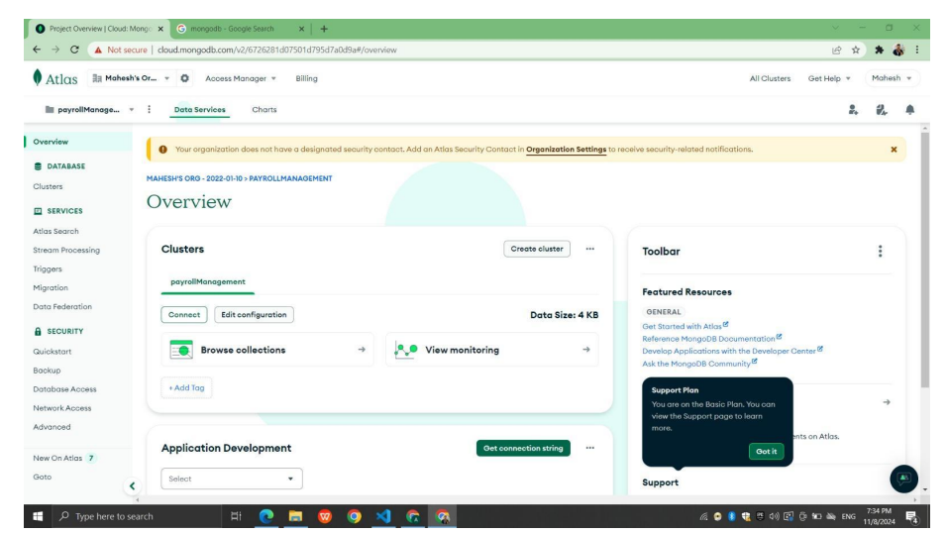

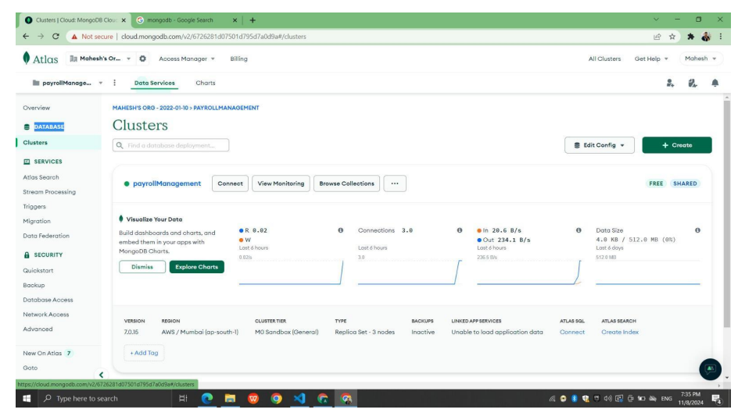

DATABASE DATA:

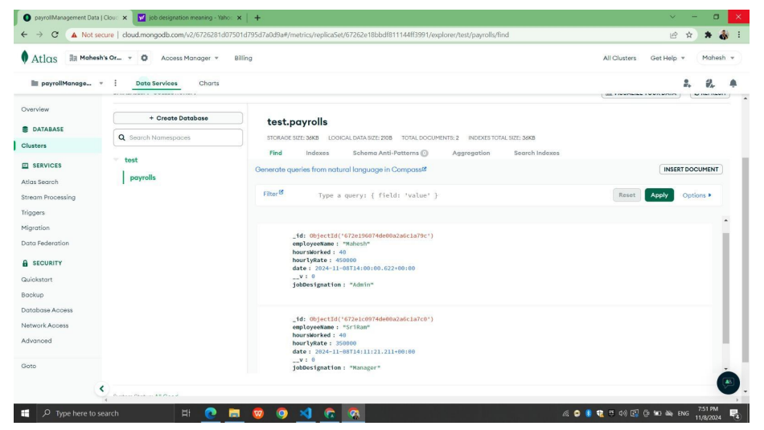

FRONT END:

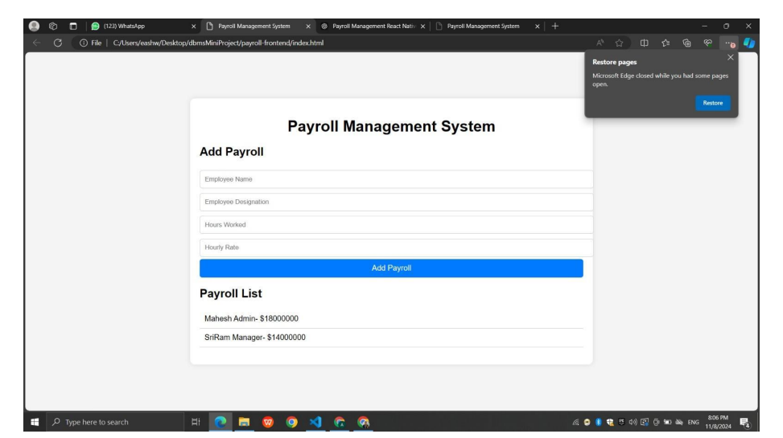

**RESULTS**

**1. Adding Employees**

**Input**:

* Enter employee name: John Doe
* Enter employee ID: E101
* Enter salary: 50000

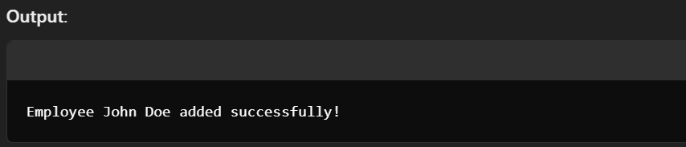

**2. Viewing Employees**

**Input**:  
Selecting the "View Employees" option from the main menu.

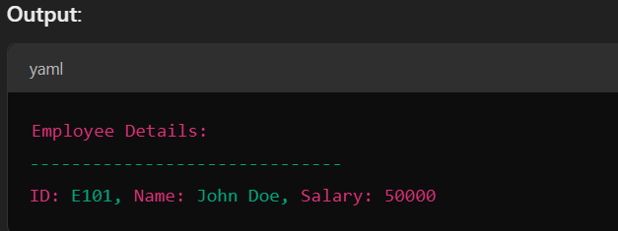

**3. Calculating Bonus**

**Input**:

* Enter employee ID to calculate bonus: E101

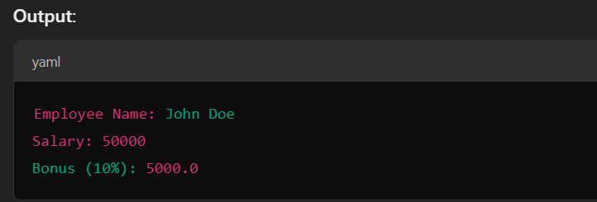 **VI.**

**CONCLUSION**

Salary Management System project was successful in achieving its primary goals of automating and streamlining payroll processes. By implementing features like employee management, attendance tracking, leave management, payroll calculation, and payslip generation, the system provided a comprehensive solution to manage payroll activities efficiently. Key benefits of the system include: ● Time Savings: Automation of payroll tasks reduced the time required for payroll processing, allowing HR staff to focus on more strategic activities. ● Reduced Errors: The system minimized errors in payroll calculation and tax deductions, ensuring employees were paid accurately and consistently. ● Enhanced Security: Implementing secure access controls and encryption helped protect sensitive payroll and employee data. ● Ease of Access: The system provided employees with access to their payslips and payroll information, enhancing transparency and trust. Overall, the Payroll Management System is a valuable tool for any organization seeking to improve its payroll operations. Future enhancements may include integrating with other HR modules, adding multi-language support, and adapting to changing tax regulations.

**VII. REFERENCES**

Salary System Basics:

URL: <https://www.example.com/salary-basics>

Database Management for Salary:

URL: <https://www.example.com/dbms-for-salary>

Web-Based Salary Management:

URL: <https://www.example.com/web-salary-management>

Salary Management Project Video Tutorial:

URL: <https://www.example.com/payroll-tutorial-video>

Textbook Reference:

"Database System Concepts" (6th Edition) by Abraham Silberschatz, Henry F. Korth, S. Sudarshan